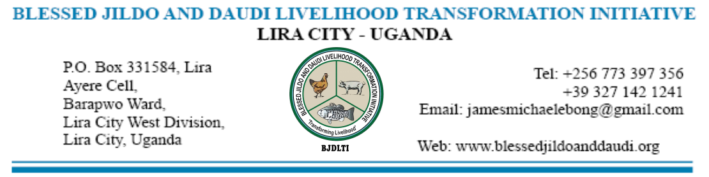

*THE BJDLTI MONTHLY UPDATE*

[**www.blessedjildoanddaudi.org**](http://www.blessedjildoanddaudi.org)

**BLESSED JILDO AND DAUDI LIVELIHOOD TRANSFORMATION INITIATIVE**

**Useful Links**

* + Home
  + Who we are
  + Where we work
  + Our Activities
  + Our Success story
  + Gallery
  + Contacts

**OUR PHYSICAL ADDRESS**

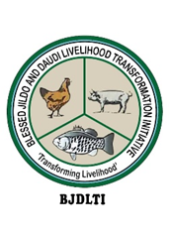

**BLESSED JILDO AND DAUDI LIVELIHOOD TRANSFORMATION INITIATIVE,**

P. O. BOX 331584

Lira City,

Lira City West Division,

Barapwo Ward,

Ayere Cell

Uganda

**OUR AVAILABLE EMAILS/PHONE/WHATSAPP CONTACTS**

**Email:** info@blessesdjildoanddaudi.com

**Email:** [jamesmichaelebong@gmail.com](mailto:jamesmichaelebong@gmail.com)

**Phone:** +256773397356/+256772910292/+256785978061/+256781955292,

**NORTHERN UGANDA**

Northern Uganda is a region that comprises a significant portion of Uganda, characterized by a diverse cultural heritage, rich natural resources, and a history marked by both challenges and resilience.

**MORE DETAILS**

**GEOGRAPHY**

Northern Uganda is geographically situated in the northern part of Uganda, bordering South Sudan to the north and Kenya to the east. It covers several administrative districts, including Gulu, Kitgum, Lira, Pader, Arua, Nebbi, and many others. The region is characterized by vast savannahs, rivers, and lakes such as Lake Albert, Kyoga and Kwania. The White Nile River flows through this region, contributing to its agricultural potential and natural beauty.

**CLIMATE**

* Northern Uganda has a tropical climate, with two distinct seasons: a dry season and a rainy season. The rainy season typically occurs from March to November, with April to June and August to October being the peak months for rainfall. The dry season runs from December to February and June to July, which can be quite hot. The climate supports agriculture, with subsistence farming being a primary economic activity in the region.

**CULTURE AND ETHNIC GROUPS**

* The region is culturally diverse, home to various ethnic groups, including the Acholi, Lango, Madi, Alur, Kakwa, and others. The Acholi, who reside mainly in the districts of Gulu, Kitgum, and Pader, are known for their rich oral traditions, dances, and cultural rituals. The Lango people are another significant ethnic group, predominantly found in Lira and neighbouring districts. They are known for their communal lifestyle and practices. Traditional dances, storytelling, and music are integral to the social fabric of these communities, with cultural events and gatherings being a common part of life.

THE MAP OF UGANDA SHOWING THE SUB REGIONS: THE LANGO SUB REGION

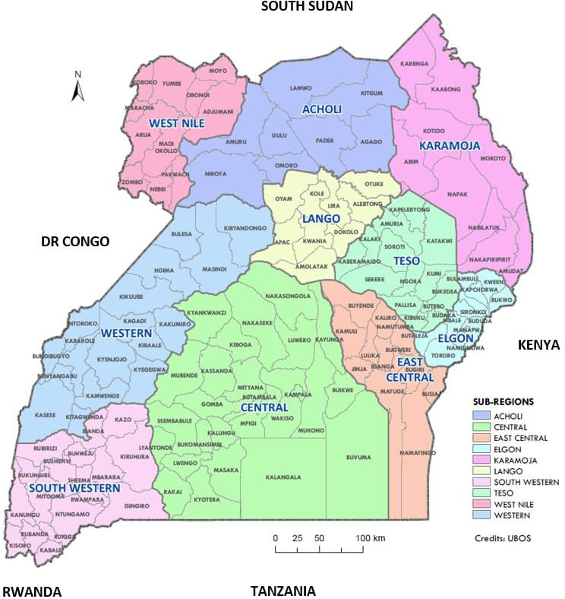

**THE MAP OF LANGO SUB REGION, GREY COLOUR**

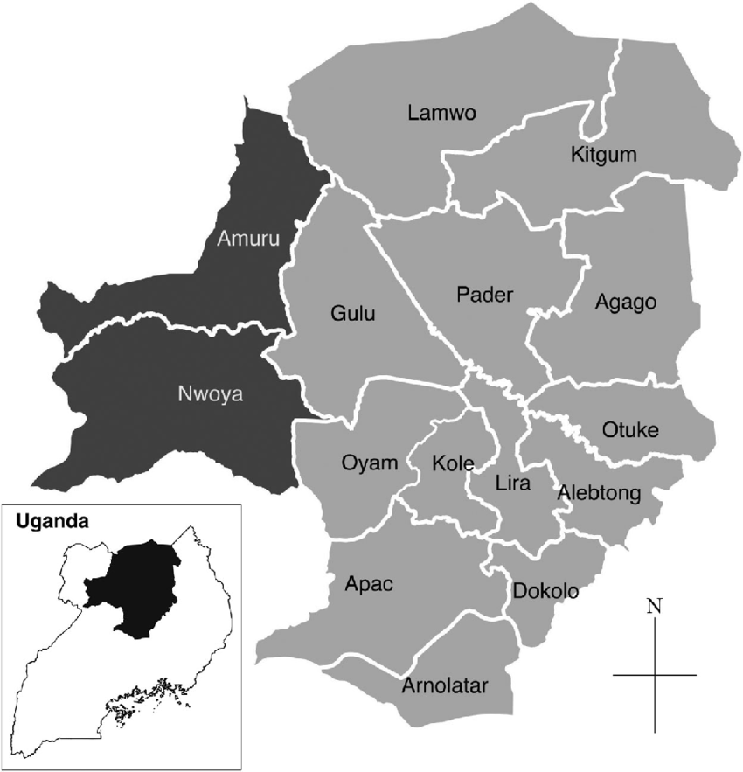

**ECONOMY**

The economy of Northern Uganda is primarily based on agriculture, with crops like millet, sorghum, beans, maize, and cassava being commonly grown.

Livestock farming is also significant, with cattle, goats, and poultry being raised in various parts of the region.

The region has potential for agro-industrial activities and is known for producing crops like simsim (sesame), shea butter, and groundnuts.

In recent years, efforts have been made to diversify the economy through trade, tourism, and small-scale industries.

**HISTORICAL CONTEXT**

Northern Uganda has a complex history, notably impacted by conflict, such as the two-decade-long insurgency led by the Lord’s Resistance Army (LRA) under Joseph Kony.

The LRA conflict, which began in the late 1980s, devastated the region, leading to loss of life, displacement of populations, and destruction of infrastructure.

Many people were displaced into internally displaced person (IDP) camps, and the conflict left deep social and economic scars.

Since the mid-2000s, the region has experienced relative peace, with efforts towards rebuilding communities, infrastructure, and supporting reintegration of former child soldiers and displaced people.

**HEALTH**

Access to healthcare has been a challenge, with many facilities recovering from the effects of the conflict. Efforts have been made to improve the health infrastructure, but rural areas still face limited access to quality medical care.

Malaria, HIV/AIDS, and waterborne diseases etc are some of the common health concerns in the region, but awareness campaigns and medical interventions can help improve the situation over the years.

**CHALLENGES**

Despite progress, Northern Uganda still faces challenges such as poverty, limited access to quality education and healthcare, and the lingering trauma from years of conflict.

Climate variability affects agricultural productivity, making food security a concern for many communities.

Continued investment in infrastructure, social services, and sustainable economic opportunities is necessary to address these challenges and build a prosperous future for the region.

**WHERE WE WORK**

Northern Uganda is geographically situated in the northern part of Uganda, bordering South Sudan to the North and Kenya to the East. It covers several administrative districts, including Gulu, Kitgum, Lira, Pader, Arua, Nebbi, and many others. The region is characterized by vast savannahs, rivers, and lakes such as Lake Kyoga, and Kwania.

**WHO WE ARE**

Blessed Jildo and Daudi is an indigenous (NGO) operating in Northern Uganda with its office based in Lira City West division. It is registered and certified by the Uganda Registration Service Bureau with the purpose of promoting and offering a comprehensive initiative programmes geared towards enhancing sustainable development and livelihood transformation.

© Copyright **Blessed Jildo and Daudi Livelihood Transformation Initiative.** All Rights Reserved

**ABOUT US**

At Blessed Jildo and Daudi Livelihood Transformation Initiative, a transformed communities through concerted interventions that mitigate the impact of poverty, climate change, drug addictions, disease, promote inclusive and sustainable development that empowers them to personally access markets for a transformed livelihood.

**WHO WE ARE**

Blessed Jildo and Daudi Livelihood Transformation Initiative is an indigenous (NGO) operating in Northern Uganda for the purpose of empowering the youth, children, orphans, vulnerable women, disabled persons, elderly persons, street children, school dropouts, drug addicts, child mothers and other vulnerable groups by creating initiatives that imparts basic life skills through vocational and improved farming practices for a sustainable livelihood and it also engages communities on environmental protection and conservation of natural resources.

**OUR PHILOSOPHY**

1. We identify committed child mothers, men, and youth leaders from among the community for planning and implementing all the sustainable development programs

2. We involve community participation in each and every step of the sustainable development programs.

3. We jointly facilitate the development of vulnerable communities to attain self- reliance.

**OUR CORE VALUES**

Integrity

Excellence

Accountability

Innovations

**STRATEGIES OF THE ORGANIZATION**

i. value additions

ii. practical skill enhancement

iii. improving livelihood

iv. resilience health

v. provision of clean water and promoting good hygiene practices

vi. partnership with institutions whom we share common values

**THE TARGET GROUP / BENEFICIARIES OF THE ORGANIZATION /PROGRAMME/ ACTIVITIES**

i. The youth

ii. The vulnerable widows

iii. Child mothers

iv. Street children

v. The elderly

vi. The orphans

vii. Nutritionally challenged persons

viii Drug addicts

ix. School dropouts

x. Disabled persons

xi. School going children

x. victims of domestic violence

x. Young adolescents

**GOALS/AIMS**

Transform communities through concerted interventions that mitigate the impact of poverty, climate change, drug addictions, disease, promote inclusive and sustainable development that empowers them to personally access markets for a transformed livelihood.

**VISION**

A sustained healthy community

**MISSION**

“To empower the youth, children, orphans, vulnerable women, disabled persons, elderly persons, street children, school dropouts, drug addicts, child mothers and other vulnerable groups by creating initiatives that imparts basic life skills through vocational and improved farming practices for a sustainable livelihood”

**THE SCOPE OF OPERATION**

BJDLTI Centre in Ayere Cell - Barapwo 40%

Lira City area 15%

Lango Sub Region 30%

Northern Region 10%

Rest of Uganda 05%

**BJDLTI RESOURCE NEEDS**

Funds

Human Personnel

Materials in kind

**NGOs/DONOR FRIENDS/FUNDING AGENCIES/BENEFACTRESSES/BENEFACTORS OF BJDLTI**

* + 1. Ana Ivey Richard of Mexico
    2. Tom Ivey Ana of Pueblo Tyres in Mexico
    3. Malfi Alfonse of Villa Di Briano in Italy
    4. Caritas Lira
    5. African Network for Change Oyam

**ORGANIZATIONAL POLICIES**

1. Code of conduct policy

2. Equal employment opportunity policy

3. Workplace health and safety policy

4. Leave and time off policy

5. Data protection and privacy policy

6. Social media policies

7. Remote work policy

8. Expense reimbursement policy

9. Conflict of interest policy

10. Whistleblower policy

11. Performance management policy

12. Email use policy

13. Harassment and discrimination policy

14. Recruitment and selection policy

15. Travel policy

16. Drug and alcohol policy

17. Intellectual property policy

18. Grievance handling policy

19. Financial policies

20. Project proposal writing and implementation policies

1. **THEME FOR THE 5 YEAR WORK PLAN**
2. Conduct 10 community mobilization and awareness sessions to identify affected families and villages impacted by child motherhood and forced marriages.
3. Organize 12 training sessions in 4 sub-counties targeting parents of child mothers, school heads, and local leaders, focusing on gender rights and strategies for reducing teenage pregnancies and promoting school re-entry for young mothers.
4. Provide 10 skills training sessions for child mothers in basket weaving, hairdressing, and stove making for income generation.
5. Deliver financial literacy training on savings and management to child mothers across 10 sub-counties.
6. Organize community sensitization campaigns in 10 villages across 5 parishes to promote positive social values supporting girls' education, including call-in and chat show broadcasts; BJDLTI.
7. Conduct business skills training for financially struggling youth to support sustainable livelihood development.
8. Host training sessions on sustainable development practices in 10 sub-counties for impactful livelihood transformation.
9. Conduct briquette-making training to promote climate change resilience.
10. Train youth in making reusable sanitary pads to support adolescents in 10 sub-counties, to improve access to affordable sanitary products.
11. Deliver agricultural skills training for youth on techniques suited to small-scale, high-yield farming on limited land.
12. Train youth in pond fish farming as an affordable protein source and potential income stream for families.
13. Facilitate a 10-day fish hatchery management course for fish breeders to lower fry mortality rates.
14. Train hatchery attendants to support emerging fish hatcheries in the Lango Sub-region.
15. Conduct a month-long poultry farming skills program for youth groups across 10 sub-counties.
16. Provide training on poultry egg incubation techniques for improved productivity.
17. Host beekeeping enterprise training to help alleviate poverty through sustainable income generation.
18. Implement mushroom cultivation training for vulnerable women in urban areas within the Lango Sub-region.
19. Organize Black Soldier Fly (BSF) farming training as a sustainable animal protein source for animal husbandry.
20. Teach organic fertilizer production techniques to enhance sustainable farming practices.
21. Train fish farmers at BJDLTI in fish pellet production to reduce reliance on commercial feeds.
22. Provide zero-grazing training for urban farmers to produce fresh dairy products within limited spaces.
23. Train street children in pig farming as a quick income-generating enterprise for poverty alleviation.
24. Conduct rabbit farming workshops for children to promote small-scale income and family nutrition.
25. Organize vegetable gardening training for young women entrepreneurs to meet market demand.
26. Provide tree nursery bed management training across 10 sub-counties to support reforestation and combat climate change.
27. Form and train groups on fish pond construction and maintenance in 10 sub-counties for sustainable aquaculture.
28. Provide hairdressing and maintenance training for school dropouts in 10 identified groups.
29. Host a 3-month tailoring, garment cutting, and fashion design training program for young mothers as an income-generating skill.
30. Conduct a 3-month hotel management and catering service training for school dropouts to improve employability.
31. Train people with disabilities in arts and crafts to empower them with sustainable livelihood skills.
32. Offer bread-baking skills training for youth to support livelihood sustainability.
33. Provide climate adaptation training to youth to respond effectively to climate change impacts.
34. Conduct horticulture and adaptive farming training to prepare youth for climate-resilient agricultural practices.
35. Train youth in urban centers on greenhouse farming for stable production despite changing climate conditions.
36. Provide training on energy-efficient kitchen solutions to equip young mothers with climate-smart cooking options.
37. Deliver nutrition training through aquaculture practices for mothers to promote resilient health in households.
38. Train fish farmers on handling and nurturing fish fingerlings to minimize mortality in hatcheries and increase productivity.
39. Showcase alternative protein sources to vulnerable groups to diversify diets and improve food security.
40. Distribute essential items to elderly individuals across 10 sub-counties to support their basic needs.
41. Build fencing around the farm to improve security and protect assets.
42. Construct a poultry house with capacity for 10,000 birds.
43. Install an overhead water tank for irrigation and general farm use.
44. Complete small housing units to provide sufficient accommodation for youth attending vocational training at BJDLTI Farm. Connect electricity to all areas of the farm.
45. Build a piggery to house 100 piglets at the BJDLTI Centre in Lira.
46. Purchase parent stock chickens to support daily hatchery operations.
47. Acquire four Friesian cows for training purposes at the BJDLTI Training Centre.
48. Construct a biogas facility for cooking and educational purposes.
49. Build a large concrete fish tank (7x10 meters) to support the supply of fingerlings for various farmer groups benefiting from BJDLTI fish training.
50. Construct three chicken coops on fish ponds to enhance pond fertility and regulate water pH.
51. Establish a larger Black Soldier Fly (BSF) farming facility to provide a consistent protein source for farm animals.
52. Construct a mushroom-growing facility (10x15 meters) to supply an alternative food source for trainees.
53. Grade and apply marram to the road connecting the farm to the main road.
54. Acquire additional land for an expanded agricultural training site to support BJDLTI’s livelihood programs.
55. Install fish cages in larger ponds to broaden learning opportunities for fish farming trainees.
56. Build a modern storage facility for various farm products at the BJDLTI centre.
57. Construct a larger grain storage facility to handle the high volume of animal feed needed year-round.
58. Purchase and install milling machines to reduce the monthly cost of purchasing animal feed.
59. Build solar drying facilities to add value to farm products for trainees.
60. Purchase additional farm tools to support the growing number of trainees.
61. Acquire salon and hairdressing tools to train school dropouts in hair styling over a three-month course.
62. Purchase tailoring machines to facilitate training for 70 street children interested in life skills.
63. Obtain a welding machine for maintenance and routine metal fabrication at the BJDLTI centre.
64. Build a multi-purpose hall to accommodate the large number of trainees participating in various programs.
65. Install more rainwater harvesting tanks to reduce water pumping costs.
66. Equip the BJDLTI centre office with new office equipment to manage the increased staff and trainers.
67. Purchase 20 laptops to teach youth basic farm management, animal feed formulation, and record-keeping.
68. Install surveillance cameras to enhance security for farm assets.
69. Purchase a projector and monitor screen to support training programs at the farm.
70. Acquire 200 conference chairs to accommodate large groups attending various training sessions.

**Our Activities**

* 1. Business skilling
  2. Innovations
  3. linkages to other services -Research
  4. Fish farming/hatchery management/pond construction & maintenance/fingerlings/fish pellets
  5. Poultry farming/egg incubation
  6. Bee keeping
  7. Mushroom growing
  8. BSF farming
  9. Organic fertilizer
  10. Zero grazing
  11. Piggery
  12. Rabbitry
  13. Vegetable growing
  14. Tree nursery bed management
  15. Horticulture farming
  16. Hair dressing
  17. Tailoring and garment cutting/fashion design
  18. Catering
  19. Arts and crafts
  20. Baking
  21. Greenhouse farming
  22. Jildo Stove Smart kitchen solution
  23. Briquettes
  24. Resilient health and nutrition
  25. Hope to the vulnerable
  26. Promoting environmental conservation and National resource governance

**OBJECTIVES**

1. To encourage and support farming as a business and enhance food security to improve community livelihoods.
2. To promote innovations in farming techniques that contribute to improved community livelihoods.
3. To support orphaned and vulnerable individuals by providing linkages and referrals to other service providers.
4. To equip vulnerable individuals with essential survival and entrepreneurial skills through workshops, information sharing, and other legal platforms.
5. To collaborate with stakeholders in community transformation initiatives.
6. To provide communities with self-sustainability programs through training in various skills such as handicrafts, embroidery, and baking, among others.
7. To conduct, publish, and disseminate research on social and economic challenges within communities.
8. To mobilize resources to support and implement initiatives that improve community well-being.
9. To foster partnerships with government agencies, NGOs, CSOs, academia, donors, and other professionals to enhance community living standards.
10. To prioritize, scale up, and sustain high-impact interventions and investments in innovations to improve health and dignified livelihoods.
11. To promote resilient health and nutrition through aquaculture.
12. To address the effects of climate change and adaptation through climate-smart agriculture.
13. To implement projects or programs that align with the organization’s objectives.
14. To undertake other activities incidental or conducive to achieving these objective

**SUCCESS STORY**

1. Strengthened community awareness on holistic approach to proper child bringing.

2. Constructed over 600 Fish Ponds in the different parts of Uganda (2008-2024), especially within Lango Sub Region (Oyam, Kole, Kwania, Apac, Lira, Amolatar, Dokolo, Otuke, Alebtong, Lira City), Portportal city, Nwoya, Soroti, Pader, Kitgum, Wakiso, Luwero, and Nebbi district.

3. Rehabilitated a number of broken fish farms within Lango Sub region

4. Supplied fingerlings to seasonal farmers for over 10 years

5. Trained a number of different youth groups on fish pond construction and maintenances

6. Have been offering invaluable advice to most fish farmers for a decade

7. Trained a number of local farmers on fish feeds formulation

8. BJDLTI has immensely impacted the livelihood of life challenged vulnerable persons in a number of communities.

9. Has over the years donated and supplied fingerlings to the vulnerable communities

10. Has mobilized a number of different youth groups to champion in the fight against poverty through different interventions

11. BJDLTI has been on the lead for many years organizing free training programmes for fish hatchery attendants.

12. Created jobs for both male and female youth

13. Donated livelihood items to the community members

14. Offered alternative protein source to the different communities where they have established fish farms

15. Trained a number of communities on poultry farming

16. Trained communities on fish pond and farm management

17. Encouraged the orphans of the farm area to be actively involved in poverty mitigation initiatives

18. Organised training on BSF Farming with representatives from all over the Lango Sub region

19. Frequently engaged the different community stakeholders in the different interventions aimed at improving livelihood

20. Has often showcased a number of the different modern farming initiatives at the BJDLTI centre at the disposition of the different community development agents

21. Multiplied the rabbits to be distributed in the community

22. Constructed 20 fish ponds at the BJDLTI centre to host varieties of fish for research purposes

23. Constructed a very unique hatchery in the whole country powered by the gravity flow of the water with conducive temperature facilitating fish hatching

24. Contributed in the pool of research for most farmers within and without the region

25. BJDLTI farmer learning centre has been opened to all the secondary schools within the area to freely learn about the different livelihood sustainable initiatives being demonstrated at the farm.

26. Trained and impacted in the lives of many on vegetable growing as a quick source of food

27. Implemented various measures at the farm that aimed at mitigating climate change and offered a pathway to alternative measures to be adopted.

28. Trained a number of the youth on welding and metal fabrication as a source of livelihood

29. Advocated for the child mothers and school dropouts to be skilled on tailoring and garment cutting/fashion design

30. Advocated for the child mothers and school dropouts to be skilled in hairdressing and the aligned treatment.

31. Organised community and trained them on the benefits of inclusive education for all the genders as the best way to cause social economic changes within the community.

**OUR TEAM**

Meet our amazing Team the one putting effort together and ensuring we achieve all our goals

STAFFING STRUCTURE OF THE BJDLTI ORGANIZATION

**BOARD OF DIRECTORS**

| **NO** | **NAME** | **POSITION** | **EMAIL** | **TELEPHONE** |
| --- | --- | --- | --- | --- |
| 1 | Fr. Michael James Ebong | ED/FOUNDER | jamemichaelebong@gmail.com | +256773397356 |
| 2 | Rebbeca Irene Adoch | Secretary | irynrebecca@gmail.com | +256781955292 |
| 3 | Silvia Akullo | Administrator | blessedjildoanddaudi@gmail.com | +256787823772 |
| 4 | Stephen Eyul | Treasurer | eyulsteven12@gmail.com | +256773877757 |
| 5 | Emmanuel Ojok | Development | ojoke831@gmail.com | +256772910292 |
| 6 | Atoke Rose | A member | atokerosemary6@gmail.com | +256785978061 |

**EXECUTIVE BOARD OF DIRECTORS**

| **NO** | **NAME** | **POSITION** | **EMAIL** | **TELEPHONE** |
| --- | --- | --- | --- | --- |
| 1 | Fr. Geoffrey Onimo | chairman | geoffreyonimo@yahoo.com | +256772570468 |
| 2 | Rebbeca Irene Adoch | Secretary | irynrebecca@gmail.com | +256781955292 |
| 3 | Stephen Eyul | Treasurer | eyulsteven12@gmail.com | +256773877757 |
| 4 | Emmanuel Ojok | Admin | ojoke831@gmail.com | +256777761596 |
| 5 | Auma Jannet | Project development | aumaj195@gmail.com | +256772910292 |
| 6 | Silvia Akullo | A member | blessedjildoanddaudi@gmail.com | +256787823772 |
| 7 | Fr. Michael James Ebong | Executive Director | Jamemichaelebong@gmail.com | +256773397356 |

**BJDLTI OFFICE STAFF AND RESPECTIVE POSITIONS**

| **NO** | **NAME** | **POSITION** | **EMAIL** | **TELEPHONE** |
| --- | --- | --- | --- | --- |
| 1 | Fr. Michael James Ebong | Executive Director | jamemichaelebong@gmail.com | +256773397356 |
| 2 | Fr. Geoffrey Onimo | Catholic Priest | geoffreyonimo@yahoo.com | +256772570468 |
| 3 | Acobi Denis Cosmas | Programmes manager | acobideniscosmas@gmail.com | +256779679310 |
| 4 | Auma Jannet | Psychologist & psychotherapist | aumaj195@gmail.com | +256772910292 |
| 5 | Adoch Rebbeca Irene | Senior Accountant | irynrebecca@gmail.com | +256781955292 |
| 6 | Akot Teddy | Accountant | akotteddy275@gmail.com | +256777285222 |
| 7 | Ojok Emmanuel | Procurement | ojoke831@gmail.com | +256777761596 |
| 8 | Acen Eunice | Project officer 1 | euniceacen@gmail.com | +256752241621 |
| 9 | Obot James | Project Officer 2 | jamesobot@gmail.com | +256782686038 |
| 10 | Bongo Jimmy | Project officer 3 | jimmybongo12@gmail.com | +256774328332 |
| 11 | Peter Ayo | Project Assistant 1 | ayopeterm@gmail.com | +256772958889 |
| 12 | Abote Stella | Project assistant 2 | stellaabote@gmail.com | +256774853893 |
| 13 | Anaso James Mary | Project Assistant 3 | anasojamesmary@gmail.com | +256782620372 |
| 14 | Anok Patrick | Admin. Ass. Legal | anokabili@gmail.com | +256759482108 |
| 15 | Ongom Isaac | Admin. Ass. Legal | ongomadero@gmail.com | +256776381217 |
| 16 | Ogwal Deogratias | Admin. Ass. Website | ogwal.deo1@gmail.com | +256778310877 |
| 17 | Awino Sarah | Admin. Ass. IT | awinosara2@gmail.com | +256774160257 |
| 18 | Komakech Innocent | Admin. Press | innocentkomakechbo@gmail.com | +256788708021 |
| 19 | Eyul Stephen | Driver | eyulsteven12@gmail.com | +256773877757 |
| 20 | Akullo Silvia | Office Attendant | blessedjildoanddaudi@gmail.com | +256787823772 |
| 21 | Atepo Joseph | Cleaner | gumjoseph@gmail.com | +256776042261 |
| 22 | Fr. Ponsiano Okalo | Peer Educator Youth | frponsokalos@gmail.com | +256772650308 |
| 23 | Pule Joshua Hero | Peer Educator | tongweno@gmail.com | +256776319542 |
| 24 | Atoke Rose | Front Office Manager | atokerosemary6@gmail.com | +256785978061 |
| 25 | Dr. Jonathan Ogom | Peer Educator Vet | jonathanongom@gmail.com | +15595561571 |
| 26 | Aramo Judith | Security | juditharamo694@gmail.com | +256773699843 |

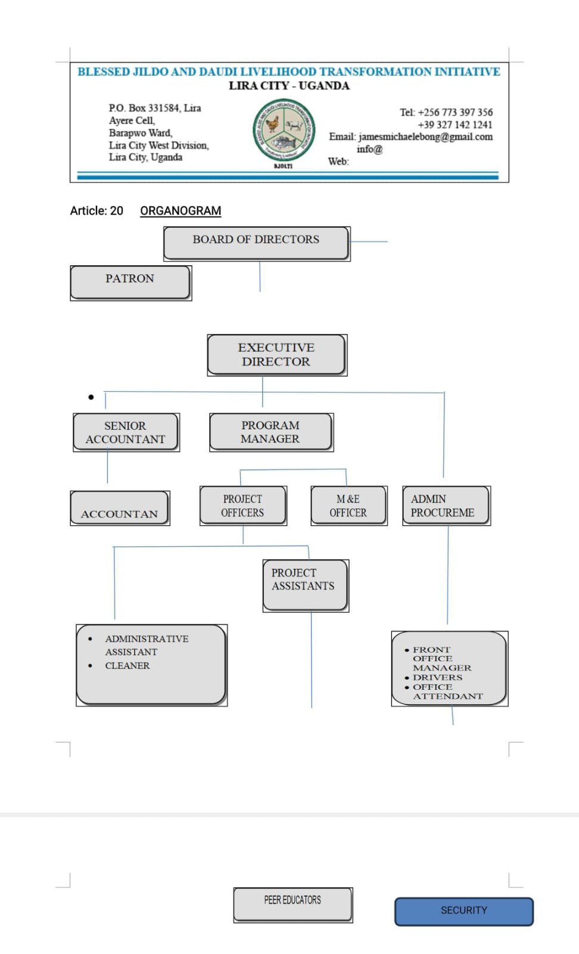



**001. Michael James Ebong**

**CEO/Founder**

Fr. Ebong has tremendous experience in working with community to achieve a desired goal and supporting the vulnerable members of the community.

He is passionate about orphans, youth, women and the elderly persons’ plight to access to justice and promotion of livelihood inclusive sustainable development initiatives for a broader community transformation.

Fr. Ebong is a priest of the diocese of Lira and currently a student in Rome pursuing a higher ecclesiastical study in Sacred Liturgy. He has master’s degree in Pastoral Theology and Liturgy respectively, Degree in Philosophy and Theology. Diploma in Social and theological studies. A wide range of certificates in social communications. He currently works as CEO of Blessed Jildo and Daudi Livelihood Transformation Initiative, linking the organisation to great partners, providing leadership, guidance and management support to the team.

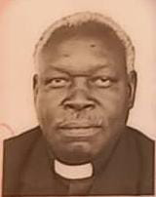

**002. Fr. Geoffrey Onimo Aporoson**

**Catholic Priest**

Fr. Geoffrey Onimo Aporoson is a priest of the Diocese of Lira and enjoys a wide span of experiences in promoting community development. He is the Patron of Blessed Jildo and Daudi Livelihood Transformation Initiative. He is very passionate and a strong pillar in championing development and proper up bringing of the infants. His love and distinctive guidance are very instrumental in shaping the destiny of BJDLTI in promoting inclusive participatory sustainable development.

**003. Denis Acobi Cosmas**

**Programmes manager**

Denis Acobi Cosmas is a Programme Manager at Blessed Jildo and Daudi Livelihood Transformation Initiatives (BJDLTI). He is responsible for leading and coordinating various community driven projects from initiation to completion. He also oversees planning, execution, monitoring, and successful delivery while ensuring BJDLTI mission of empowering communities and driving social change; details the project plans that outlines goals, objectives, and deliverables, schedules, budgets and resource allocations for each project, ensures the alignment with BJDLTI strategic objectives. He holds Bachelor degree in Vocational Agriculture Extension and Education from Kyambogo University (2009), and currently in pursuance of Masters of Science degree in Food Security and Community Nutrition from Gulu University. Denis comes with over 8 years of field-based project management experience in areas of agriculture, food security, livelihood, with integrated access to finance, digitization of agri-extension and advisory services, business skills development, climate change resilience (adaptation, mitigation, climate smart agriculture and sustainable agriculture practices), including leading sustainable inclusive community development initiatives and humanitarian emergency response leverage expertise in agriculture and livelihoods to drive impactful life changes. Professionally Denis is an Agriculture Extensionist, committed to designing, implementing, and overseeing an effective high-impact programmes in the fields of agriculture, food security, livelihoods, climate change resilience, integrating access to financial services, business skilling and digitization to enhance access to different services among rural communities, smallholder farmers, rural producer groups (VSLAs, Farmer Groups, Agribusiness SMEs, SACCOs and District Farmer Associations). He also proficient in ICT and application software (Microsoft Word, Excel, PowerPoint, and Internet), concepts of gender & disability inclusion and advocacy for policy influence and change in both fragile context and conflict environment. His experiences in sustainable agriculture and community livelihoods linked to Markets Systems Development, Agri-Enterprise Models and Food Security that gives him additional advantage to implement diverse livelihood transformation programme.

**004. Auma Jannet**

**Psychologist & psychotherapist**

**Contact him**



**005. Adoch Rebbeca Irene**

**Senior Accountant**

Rebecca Irene Adoch is a senior Accountant at Blessed Jildo and Daudi Livelihood transformation Initiatives (BJDTI). She is responsible for overseeing the finances and the internal control systems of accounts of BJDTI, without compromising any Principles of Accounts and the organization integrity, she is reliable due to her vast experience in handling different project funds from different

Donors prior to working with BJDLTI like Private Sector Foundation Uganda with its Project of Youth Empowerment Project under skills development facility windows UGX 50m (13,000 dollars), Uganda Fund with its project of Sexual Gender based violence (SGBV) UGX 800m (200,000 dollars), CIV fund with its project of upscaling women and economic development UGX120m (20,000 euros), Care International with its project of natural resource management (Eco system Risk Reduction 200m {50,000 euros}) and finally GIZ with its Basic Economic skills of 350m and 800m (200,000 euros).

Adoch Rebecca Irene holds, A Bachelor of Business Administration (Accounting Option) from Gulu University in 2013, she has 11 years working experience from different organizations which puts her in a better position of handling financial obligations of the organization. She is currently Pursuing her CPA level one.

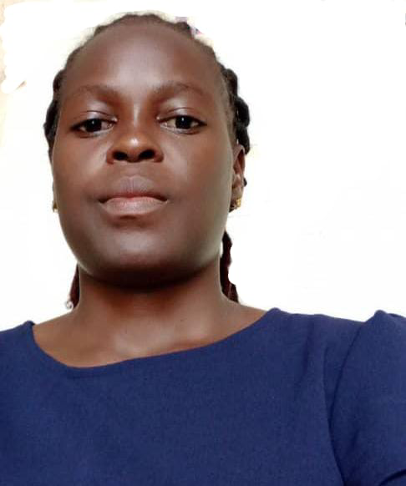

**006. Akot Teddy**

**Accountant**

Akot Teddy is the accountant of Blessed Jildo and Daudi Livelihood Transformation Initiative. She is assigned with the responsibility of managing the financial health of the organization. These includes preparation of budget, financial reporting, monitoring expenses, filling monthly returns, ensuring compliance with accounting principles and regulations. She plays crucible roles in enabling that Blessed Jildo and Daudi achieve its mission by maintaining transparency and accountability in financial operations.

Akot Teddy holds a diploma in Business Studies where she majored in accounting option, holds a degree in Business Administration from Gulu University and at the moment pursuing a Post graduate diploma in finance management. She has over 8 years of experience in finance management, business oriented, hardworking, good quality reporting with vast skills in computer software thus promoting financial health of the organization, effective reporting, transparency and accountability.

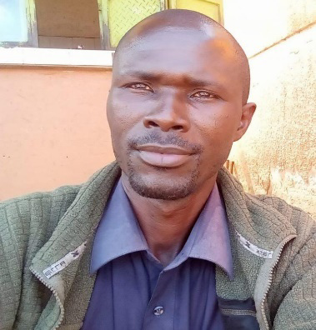

**007. Ojok Emmanuel**

**Procurement**

**Contact him**

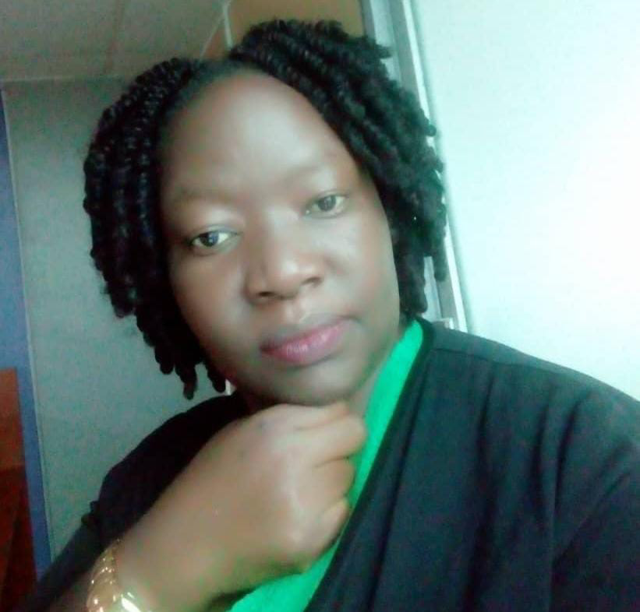

**008. Acen Eunice**

**Project officer** 1

Eunice Acen is a dedicated development professional with over 10 years of experience working with youth and vulnerable communities. She holds a Master’s degree in Development Studies, a Postgraduate Diploma in Project Planning and Management, a Bachelor’s degree in Development Studies, and a Diploma in Social Work and Social Administration, with a specialization in working with children. Her expertise lies in youth empowerment, livelihoods development, social inclusion, and disaster resilience.

Eunice has a proven track record in training and mentoring young people, implementing Village Savings and Loan Association (VSLA) methodologies, and coaching individuals to achieve self-reliance. She is skilled in project planning, implementation, monitoring, and evaluation. At Blessed Jildo and Daudi Livelihood Transformation Initiative (BJDLTI), Eunice is actively involved in project proposal writing and the development of key project documents, including strategic plans, work plans, and reports.

Eunice is passionate about promoting sustainable development through education, capacity building, and community-driven interventions. Her work reflects her commitment to creating inclusive and resilient communities.

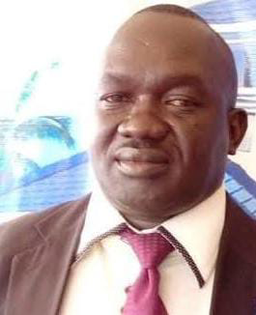

**009. Obot James**

**Project Officer 2**

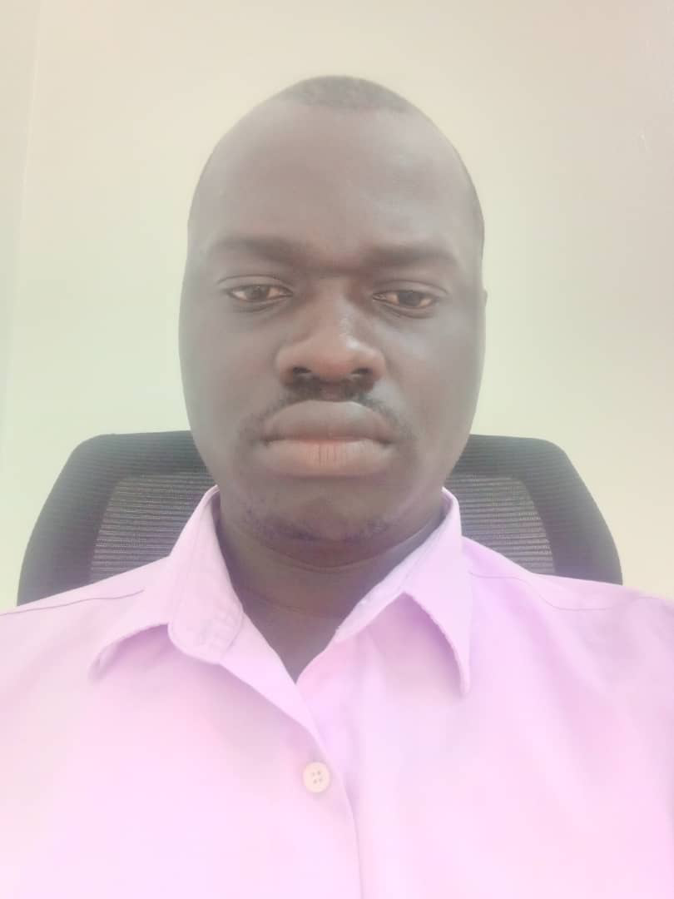

**010. Bongo Jimmy**

**Project officer 3**

**011. Peter Ayo**

**Project Assistant 1**

**012. Abote Stella**

**Project assistant 2**

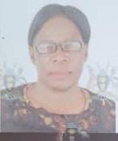

**013. Anaso James Mary**

**Project Assistant 3**

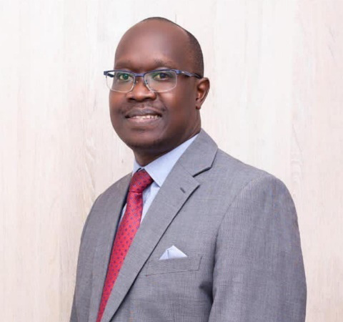

**014. Anok Patrick**

**Admin. Ass. Legal**

Patrick is our Admin Assistant on legal matters at Blessed Jildo and Daudi Livelihood Transformation Initiative. He enjoys an extensive back ground in Leadership in Banking, spanning 15 years, specializing in Commercial law, project financing, corporate restructuring, equity and debt finance and Corporate Governance.

Patrick also advises on corporate strategy, business development, capital and debt financing, risk management, compliance and governance controls.

He is an experienced partner of the KMA Advocates Full-time Jan 2019 - Present 5 yrs 11 mos Kampala, Uganda.

He is an advocate of the High Court of Uganda and all Courts subordinate thereto. He is a member of the Uganda Law Society (ULS) and the East African Law Society (EALS) and a member the Insolvency Practitioners in Uganda.

Contact Anok:

Email: [anakabili@gmail.com](mailto:anakabili@gmail.com)

Tel: +256759482108/+256772482108

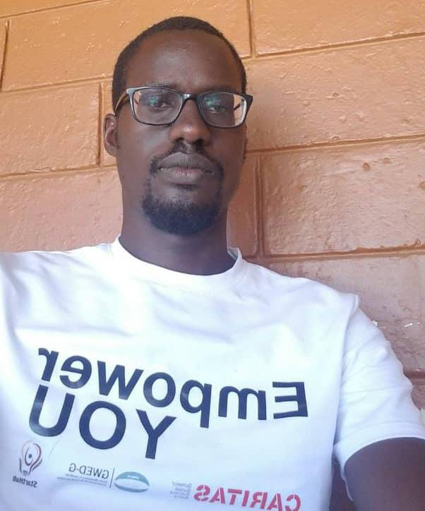

**015. Ongom Isaac**

**Admin. Ass. Legal**

Counsel Isaac Innocent Ogom is one of the two celebrated legal personnels that BJDLTI is blessed with. His role is key and paramount in shaping the legal framework and policy alignments of the BJDLTI. He holds a Bachelor of Laws Degree from Makerere University, Kampala, and currently works as Admin. Assistant for Legal matters at BJDTLI. He has also worked as an entrepreneurship trainer at StartHub Africa Ltd. Part of his responsibilities include drawing training manuals, mentoring & parting business skills to youth led entrepreneurs within Lira City under the EMPOWER YOU Project funded by CARITAS, Switzerland. As a farmer himself, Isaack has found purpose in enabling and sharing in the entrepreneurial spirit alongside like-minded youths. His expertise is based towards ensuring strong organizational structures that revolve around strong corporate governance policies and practices to guarantee sustainability of organizations.



**016. Ogwal Deogratias**

**Admin. Ass. Website**

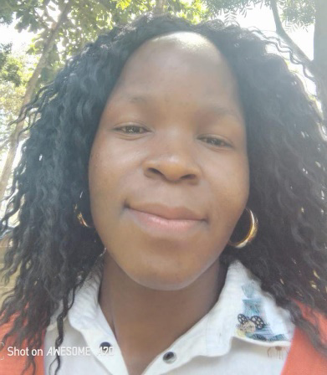

**017. Awino Sarah**

**Admin. Ass. IT**

Sarah serves at Blessed Jildo and Daudi Livelihood Transformation Initiative as the IT assistant. She is undoubtedly a very dedicated health informatics researcher currently pursuing a pioneering role in this dynamic field. Her academic and professional journey has equipped her with an understanding of how technology can transform healthcare delivery and improve patient outcomes. She is particularly interested in the intersection of climate and health, recognizing the profound impact that environmental changes have on public health.

Sarah specialized in leveraging advanced data science methodologies to address complex challenges in healthcare. By utilizing big data analytics and machine learning techniques, she generates data-driven insights that inform health practices. Her experience as a Data Officer has sharpened her skills in data management, analysis, and visualization, allowing her to interpret complex datasets and communicate findings effectively to diverse stakeholders.

Additionally, her background in ICT support has provided her with a solid technical foundation, enabling her to troubleshoot issues and implement technological solutions. Sarah's role as a Human Resource Officer has further enhanced her interpersonal and organizational skills, fostering collaboration within multidisciplinary teams.

As she advances in her career, she remains very eager to explore new research opportunities that combine with her interests in health informatics, climate change, and data science. She is committed to contributing to evidence-based solutions that address the challenges-health and environmental sustainability. Her goal is to make a meaningful impact in the field, utilizing her expertise to promote the health and well-being of communities in an ever-evolving world.

**018. Komakech Innocent** 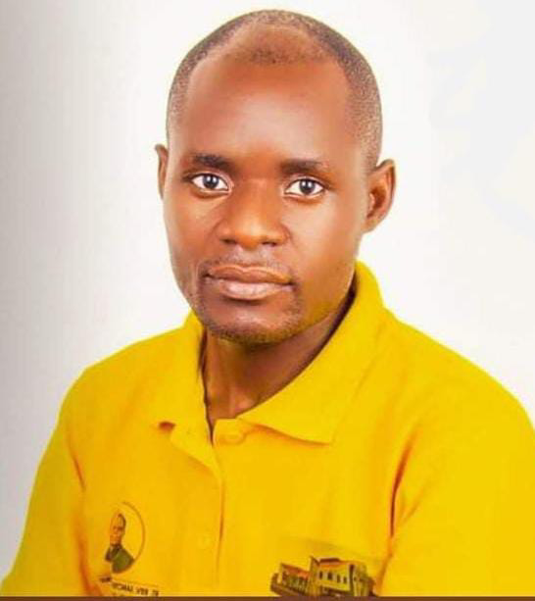

**Admin. Press**

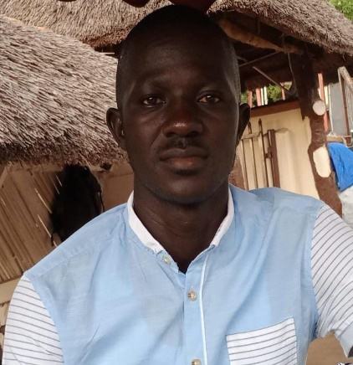

**019. Eyul Stephen**

**Driver**

Eyul Stephen is a driver at blessed Jildo and Daudi livelihood transformation initiative (BJDLTI). He is responsible for operating organisation's vehicle, safety transportation of employees and delivering goods/cargo of the organization, proper maintenance of the vehicle. He plays important role to ensure blessed Jildo and Daudi achieves its goals and objectives  
Eyul Stephen has O level certificate a valid driving permit of classes B, C1, C, CE. He is a self-motivated, hardworking with 15years of experience as a driver.

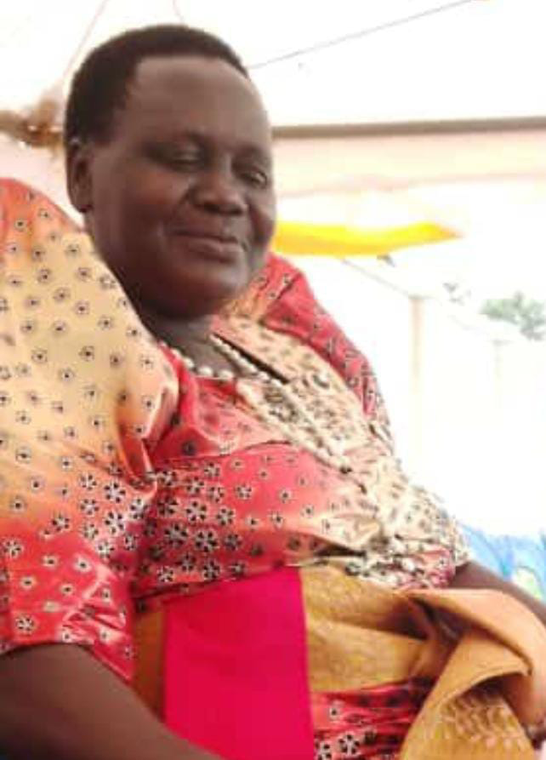

**020. Akullo Silvia**

**Office Attendant**

Silvia Akullo is the Office Attendant at Blessed Jildo and Daudi Livelihood Transformation Initiative (BJDLTI) and doubles as the Supervisor of the BJDLTI Farm section activities. She is a strong pillar at BJDLTI because of her vast knowledge and experience in handling the varied projects at the farm.

She is a dedicated and cooperative team member of the BJDLTI Farm centre. Silvia is also one of the core team members that supervises the BJDLTI Farm activities and the personnels at the farm. She is a very committed person in implementing BJDLTI development activities on the farm. She loves her job and treats our clients with respect.

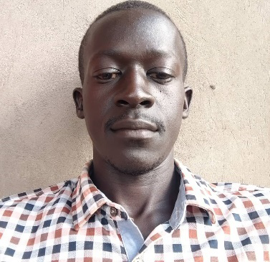

**021. Mr. Atepo Joseph**

**Cleaner**

Mr. Atepo is not just a cleaner by coincidence at Blessed Jildo and Daudi Livelihood Transformation Initiative (BJDLTI) but he is a good compound specialist. He knows compound management quite well. He is very passionate at his work and he serves BJDLTI with zeal and love. He is very good at his work and does machine services by himself. He is responsible for operating the organisation's farm machines. He plays an important role to ensure blessed Jildo and Daudi achieves its goals and objectives. He is a self-motivated and hardworking person. He holds a UCE certificate of Education.

**022. Fr. Ponsiano Okalo** 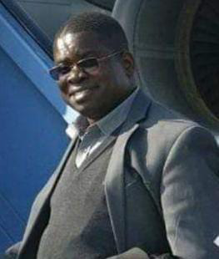

**Peer Educator Youth**

**023. Pule Joshua Hero**

**Peer Educator**

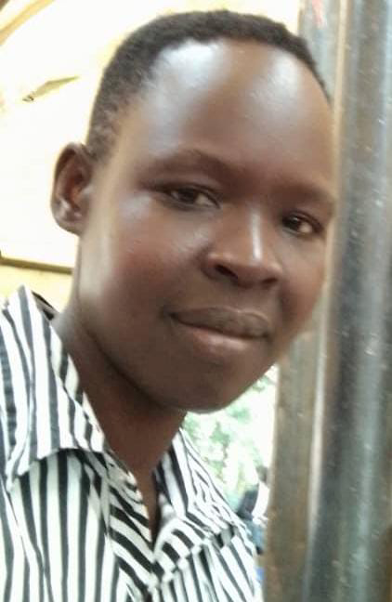

**024. Atoke Rose**

**Front Office Manager**

Atoke Rose is the Front Office Manager of Blessed Jildo and Daudi Livelihood Transformation Initiative (BJDLTI) and doubles as the manager of the BJDLTI Bookshop. She also controls all transactions involving the use of mobile money services. She is an honest, sincere and dependable team member. Rose is also one of the core team members that supervises the BJDLTI Farm activities and the personnels at the farm. She is a very committed and very easy person to work with. She serves our clients with love and respect. She loves her job and we at BJDLTI are very proud of her.

**025. Dr. Jonathan Ongom**

**Peer Educator Vet**

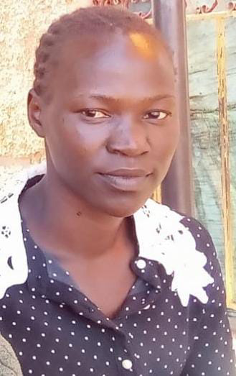

**026. Aramo Judith**

**Security**

Aramo Judith is the Security Officer at Blessed Jildo and Daudi Livelihood Transformation Initiative (BJDLTI) and doubles as the in charge of the daily farm running activities. She likes her work and attends to it with passion. Her love for work is seen in her commitment to take care of hundreds of rabbits, birds, vegetable garden, fish ponds and the hatchery. She is an industrious person that we are blessed to have.

She is a dependable team member. She is a very positive person and collaborates very well with her immediate supervisors. She is very committed and hard working. She serves our clients with love and respect. She qualified with a paper in General Crop production and is passionate about her career.

**BJDLT ASSOCIATE REGISTERED MEMBERS 2024/2027**

1. Tom Ebong

Economist

2. Dr. Walter Ongom

Medic

3. Dr. Jacob Eyul

Medic

4. James Ekonga

Accounting/Finance

5. Denis Apoo

Teacher/Technical

6. Geoffrey Okello

Plumber

7.Sebastiano Aliro

Electrician

8. Sr. Stella Ababiku

Religious/ Headteacher

9. Paul Website designer